**Deployment Of App In IBM Cloud**

Name

Sandhiya

a

Roll no

312419104118

Team ID

P

NT2022TMID

28174

Project Name

Inventory Management System for

Retailers

**TASK**

➢

Containerize the

App

➢

Upload image to IBM Container

Registry

➢

Deploy in Kubernetes

Cluster

**Containerize the App**

❖

Docker image

creation

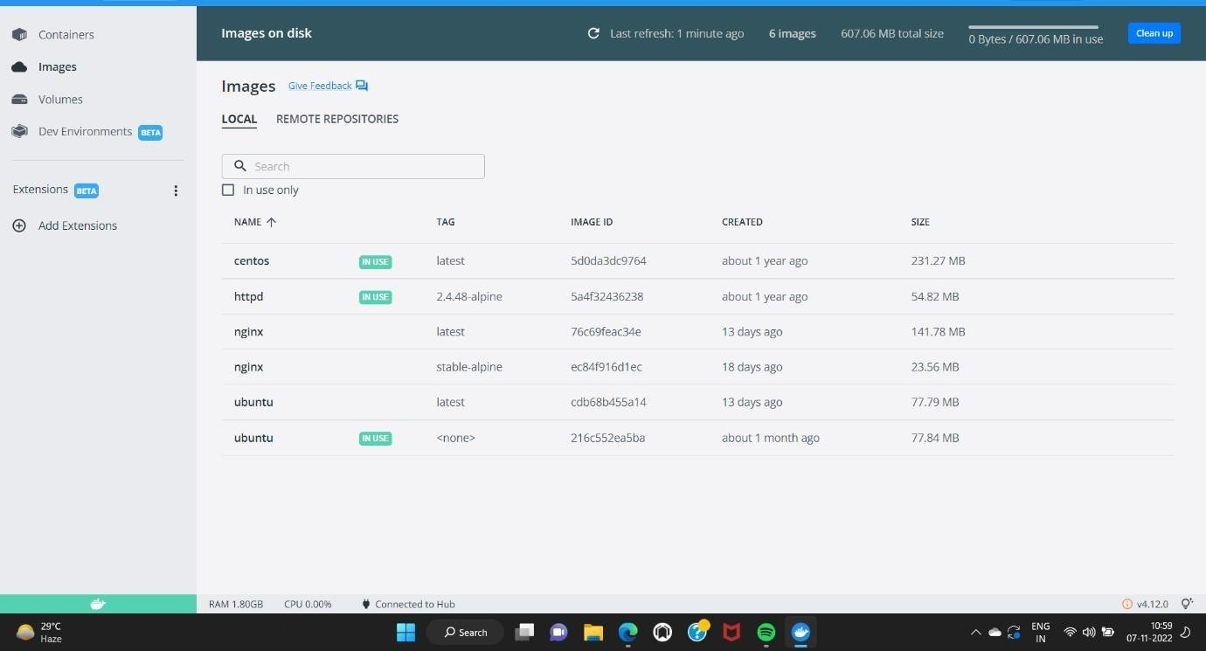

**Upload image to IBM Container Registry**

**Deploy in Kubernetes Cluster**

Deploy on kubernets

